Dear Sir/Madam

I am writing to you as I feel a patriotic duty to bring some focus back to the science and data around this Covid19 issue. The current approach that our government and advisory panels are driving, is increasingly inexplicable when considering the science and the data. It is becoming obvious that we need to foster more open discussion on the big picture here. Is there a good technical reason to continue with the current level of, quite frankly, destructive interventions?

Firstly, I would like to bring to your attention some basics in this matter (section A), and then back up the discussion with more detailed and referenced science (section B). The essence of this document is now agreed with by a very large (and rapidly growing) community around the world. Countless medical and technical professionals are at this stage, aghast at what is happening.

SECTION A – The Basics:

As the Epidemic morphed into a Pandemic as determined by the WHO, data from China, Italy, SE Asia, and other European countries gave us a clearer picture of how this particular virus was behaving. This data informed us regarding important aspects of Sars-CoV-2 including transmission, immunity, people most likely to succumb to the virus, ICU admission rates, death rates, seasonality, predisposing factors and much more.

The Global response to the pandemic, apart from some notable exceptions, was to as quickly as possible lock down our communities and our economies and flatten the curve, thus buying time to allow us deal with the sick and to continue the race for vaccines and therapies. This was an understandable and intuitive reaction and to some extent has been a success.

As of week 33 of ONS reporting we’ve had 52,026 of our citizens have lost their lives, that mentioned COVID-19 on the death certificate, and my condolences to all their families and friends. That said, it is important to note that approximately 95% of the deceased were never admitted to ICU to attempt to save them. This is almost certainly because they were so aged or suffering from other serious conditions, that it would have been unethical to attempt to save them with intensive interventions. This, along with the fact that median age for the deceased was 83, must be kept clearly in mind when considering impacts.

At this point it is important to state a few indisputable facts that have emerged before and during this pandemic:

- SARS-CoV-2 is a Coronavirus that shares many structural and behavioural properties with many other coronaviruses that affect human beings. This Coronavirus was referred to as novel. This is somewhat of a misnomer.
- Face Masks at the height of the Pandemic were considered unimportant, we were regularly informed of this from experts through our media.
- Covid 19 (the condition produced by Coronavirus) is a condition that predominantly affects the elderly and immunocompromised (as mentioned above, median age of death is 83yrs), it does not affect certain other groups like children and pregnant women in a way that Influenza, another seasonal killer, does.
- A significant number of people succumb to Influenza virus each year, this can vary in its severity and impact; for example, the 2018 flu season was particularly severe in the UK, causing approximately 20,000 excess deaths in the month of January alone. The 2019 flu season was comparatively lighter, thus paving the way for a pathogen such as SARS-CoV-2 to heavily impact the susceptible in our population – a large group who would have ordinarily experienced higher mortality during the preceding Flu season.
- The death rate has been similar throughout the World (approx. 500 (+/-) deaths per million). This, and I cannot emphasise this enough, is overwhelmingly independent of lockdown measures.
- The reaction of most Governments has been largely based on the predictive models of Imperial College London. This model and the predictions made were mind-boggling – 510,000 people could die from the virus if no action was taken. The reality we now know is to be around 50,000. We experienced a similar impact as Sweden did (they with no lockdown, no masks). Overwhelmingly it was limited to the aged / co-morbid, with care homes contributing to the majority of the deaths.

The following facts are also indisputable:

- Sweden, who were vilified for their approach, has had a very similar death rate to other countries. Sweden enacted a light touch response to SARS-CoV-2 (smart social distancing, smaller crowds, emphasis on hand hygiene), while largely leaving their economy, including schools, open. According to the now heavily questioned Imperial College London model, Sweden should have had 11-17 times the number of deaths that it actually had. This has been backed up by studies and peer reviewed publications such as The Lancet. Hard lockdown has little impact on the death rates when compared to social distancing, hand washing, masks if symptomatic etc. This is a hugely important point. Sweden’s science-based policy has allowed them to emerge from the pandemic with many sectors of its economy and public health intact. It is close to achieving Herd Immunity, and all of this was possible without any lockdown.

- Like most countries in Europe Sweden has little or no deaths or ICU admissions from Covid 19 in recent weeks, without requiring any of the measures imposed by the vast majority of European countries
- Sweden is not on its own in following this course. There are some contrasting examples of hard lockdown v light touch response in the US and in South America. Peru imposed a hard lockdown while its neighbour Brazil was attacked in the media for their softer approach. Again, we see similar death rates from both. i.e. the military-enforced lockdown in Peru not showing any significant benefit over Brazil’s lack of any significant lockdown.

Sweden “modelling” versus actual reality is illustrated below:

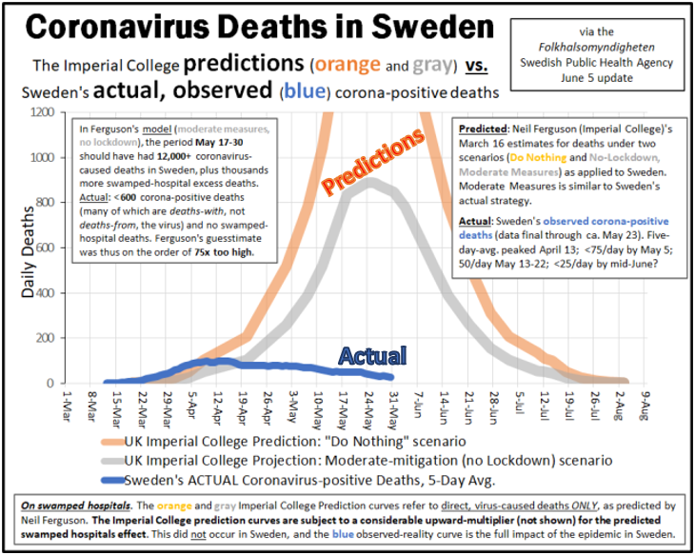
Ref: https://swprs.org/covid19-lethality-how-not-to-do-it/

SECTION B – The Details:

B1: EPIDEMIOLOGICAL REALITIES
2013 Nobel Laureate, Stanford Professor Michael Levitt

At this point it is important to invoke some fundamental mathematics and science.

Professor Michael Levitt, Nobel prize winner for Chemistry in 2013 and many other experts in epidemiology, have been deciphering the data provided by the viral spread. Professor Levitt has been interviewed a number of times over the last few months. He concluded that the curves produced by death rates were not exponential as per the Imperial College London models, and rather followed what is referred to a Gompertz phenomenon i.e. steep sharp rise followed by a flattening, followed by a long slow tail. This occurs as the virus “burns out” (the susceptible population pass, and ultimately a herd immunity develops). This has been the way countries have played out time after time. Notably, this behaviour mirrors influenza epidemic behaviour almost perfectly – this reality should have been the key focus since March. Please see example curves below. Remember, this is the actual data – not modelling.

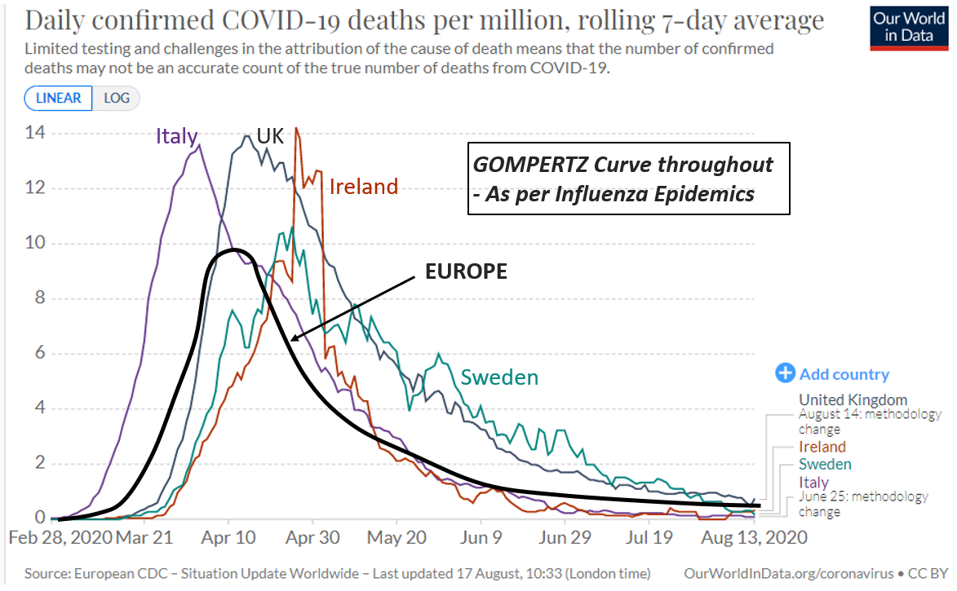

Ref: “Predicting the Trajectory of Any COVID19 Epidemic From the Best Straight Line” - DOI: https://doi.org/10.1101/2020.06.26.20140814

There are endless references showing the seasonal Gompertz distribution of influenza epidemics – just one sample below – note the almost exact match with SARS-CoV-2 behaviour. This has been known for a century or more:
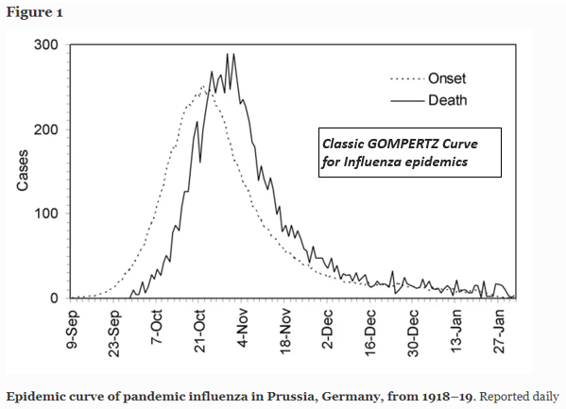
Ref: “Time variations in the transmissibility of pandemic influenza in Prussia, Germany, from 1918–19” - Theoretical Biology and Medical Modelling volume 4, Article number: 20 (2007)

Note also that one of the world’s top professors in epidemiology / evidence-based medicine (Stanford Prof John Ioannidis) called this out back in March 2020 – he was horrified at what the world was embarking upon, based on dreadfully poor evidence:

Ref: https://onlinelibrary.wiley.com/doi/full/10.1111/eci.13222

MOST IMPORTANTLY, the impact of Covid 19 in Europe is not nearly what people perceive. As pointed out by Professor Levitt repeatedly, the excess mortality from Covid 19 is not very much greater than the excess mortality observed during the 2018 influenza season. The European mortality data can be pulled by anyone who cares to do so, and it tells a clear story of reality:

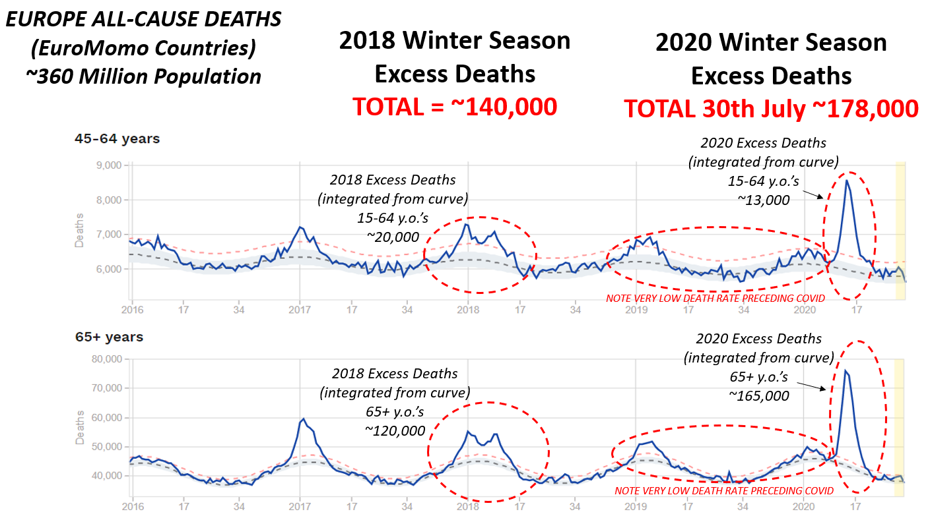
Ref: https://www.euromomo.eu/graphs-and-maps

Note 1: The SARS-CoV-2 “season” was very short and sharp in its impacts, which is not surprising considering the very soft influenza seasons directly preceding SARS-CoV-2 in Europe.
Note 2: The impact seen could be challenged by claiming that “lockdown measures made it lower than it might have been.” This would be a misleading claim, as there are now multiple published analyses showing that lockdown achieved little or nothing –a sample set collated here: https://www.dropbox.com/home/LOCKDOWN%20NO%20GOOD%20-%20STUDIES

Another key point is that this virus should never have been compared to the 1918 Spanish Flu. Below data from Sweden shows the difference in scale, in terms of impact per million people:
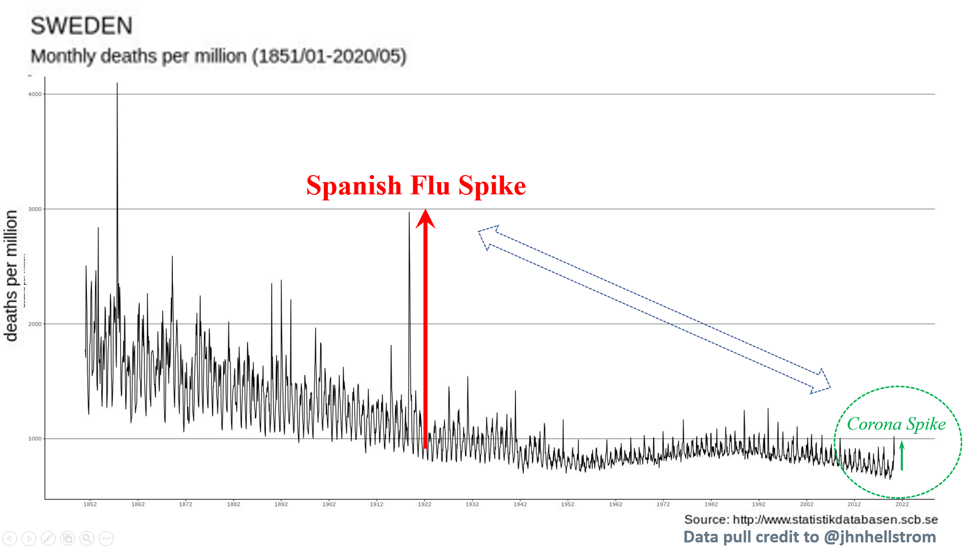

Note also how the actual Covid19 impact in Sweden is barely discernible from that of influenzas in many months during previous years. Note also that the so-called “second wave” of 1918 Spanish Flu is widely accepted to have been a different virus from the one which caused the first (Spring) wave. An entirely different demographic was impacted during the second wave. Most likely it was resurgence of a tough influenza strain from the 1870’s – hence the older people in the population were spared, while the younger ones with no immunity were hit the hardest.

B2: IMMUNOLOGY REALITIES:

Points from Emeritus Professor of Immunology, Beda Stadler (Switzerland)
- The virus is indeed new, as all previous new viruses were “new”. However, it (unsurprisingly) shares many structural properties with prior coronaviruses in this family
- It is now clear through many publications over past months that our immune systems recognize these priorly present protein structures when exposed to Sars-CoV-2 leading to a very large extent of immunity in our population from the get-go
- This explains the fact that the virus has not come within a mile of the mortality projections of ICL etc. – as in the population it very rapidly “stumbles upon the myriad people who are essentially immune/protected already” – this is “cross-immunity” from prior coronaviruses, and is widespread in the population
- He is emphatic that once the virus has passed through its natural cycle, then a population has de facto herd immunity protection – even though only maybe ~10% of people will show positive in an antibody test.
- He explains that that is why the mortality and ICU loading has collapsed across most/all of Europe – it is clearly the passing of the susceptible, the development of de facto herd immunity, and also some seasonal mechanisms. But in any case, this is over in Europe until next winter, where more susceptible people will be seasonally affected.

Final key point – contact tracing of symptomatic Covid patients through their direct family members whom they share houses with – shows 70% or more never exhibit infection or symptoms. This illustrates Professor Stadler’s point i.e. the majority of people are ALREADY de facto immune, from cross-immunity to prior coronaviruses etc.

Ref: https://medium.com/@vernunftundrichtigkeit/coronavirus-why-everyone-was-wrong-fce6db5ba809
Discussion with Professor Stadler: https://youtu.be/GBRcK-od50Q

B3: MANDATORY MASK REALITIES

Experts in the UK and around the World were at best sitting on the fence re the use of masks throughout the pandemic, as the empirical evidence backing up their use if anything pointed to very little benefit in viral transmission mitigation. In any case, given the reality described by the experts above, there is no possible scientific justification for mandating masks at the END of an epidemic. If anything, we run the risk that we will impede safe development of further herd immunity dynamics in our population. This mandate, if anything, could put the most at-risk at even greater risk next winter; an ironic outcome not considered by our “experts”.

The following May 2020 publication alone took the time to compile 14 randomized control trials in mask use and viral transmission. It concluded that masks were near-useless as a mitigation measure. However, there are many more publications over the past 30 years which are aligned in concordance with this conclusion. Note that the WHO themselves have been careful to note that they are NOT instructing governments to implement mandatory masks. Thus, the implementation of mandatory masking has clearly become a politically-driven endeavour:

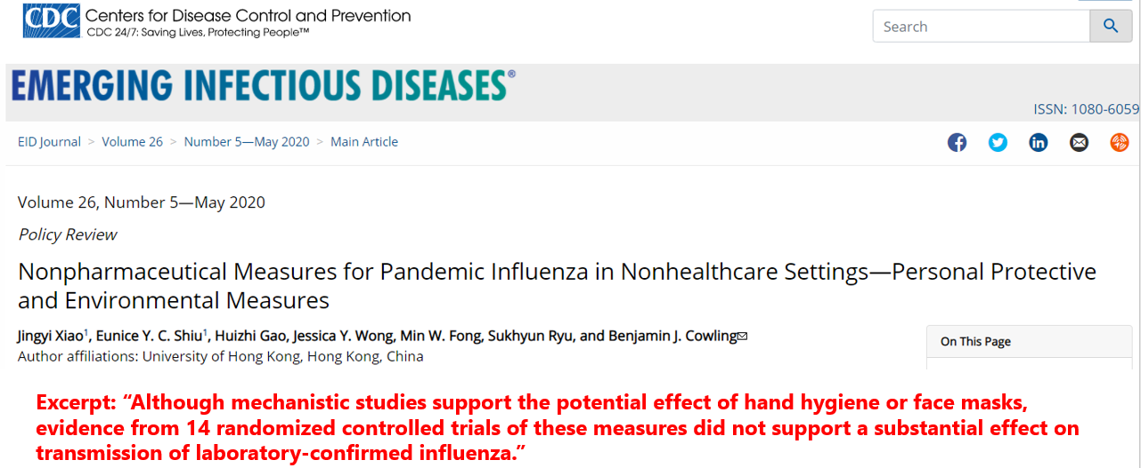

Ref: https://wwwnc.cdc.gov/eid/article/26/5/19-0994_article

B4: SEASONALITY / REGIONALITY REALITIES

The seasonal nature of this virus needs to be debated and properly explained. It appears to follow a seasonal pattern as based on the work of Dr. Edward Hope-Simpson and fits very neatly with his work. Studying the impact of seasonal viruses over 50 years, Hope-Simpson illustrated that the shape of the curves depends heavily on what region of the World is involved.

Still debated, the drivers of viral triggering include latitude, UV flux, human immune system cycles, humidity etc. In any case, this helps to explain the shape of the mortality/impact curves depending on these variables - showing why the virus has spread in certain US states like New York (North Temperate region) versus Florida (North tropical) and why rising cases now in places like Melbourne and New Zealand are expected. This rise in cases in New Zealand should come as no surprise.

Note just one example below with patterns from Hope-Simpson’s book and also some sample countries. Europe locked down in March same as Peru. Brazil however did not lock down – but the Covid curves simply follow the seasonal pattern regardless. In other words, seasonal/regional vectors dominate – similarly in Northern versus Southern USA regions:

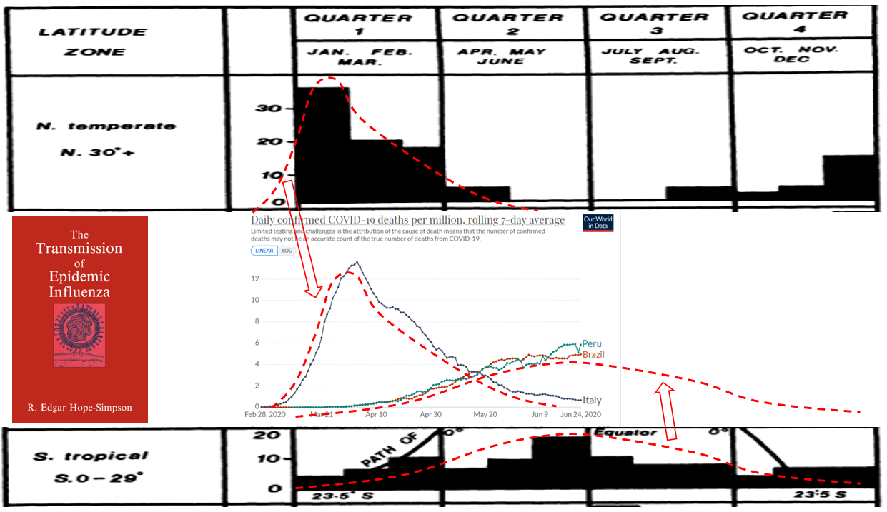

You can download Hope-Simpson’s book here – he spent >50 years researching viral transmission, after setting up the UK’s first influenza transmission research centre - in 1933: https://www.dropbox.com/s/4yda40j4hf9nbad/11th%20The%20Transmission%20of%20Influenza%20BOOK.pdf?dl=0

There is so much data emerging on this seasonal reality. But for brevity I’ll just include a picture of the striking seasonal/regional patterns being seen in the USA. Please note that all graphs are “deaths per million people”, and that the Y-axis scale is identical - so that you can clearly see the dramatic difference in mortality impacts between regions):

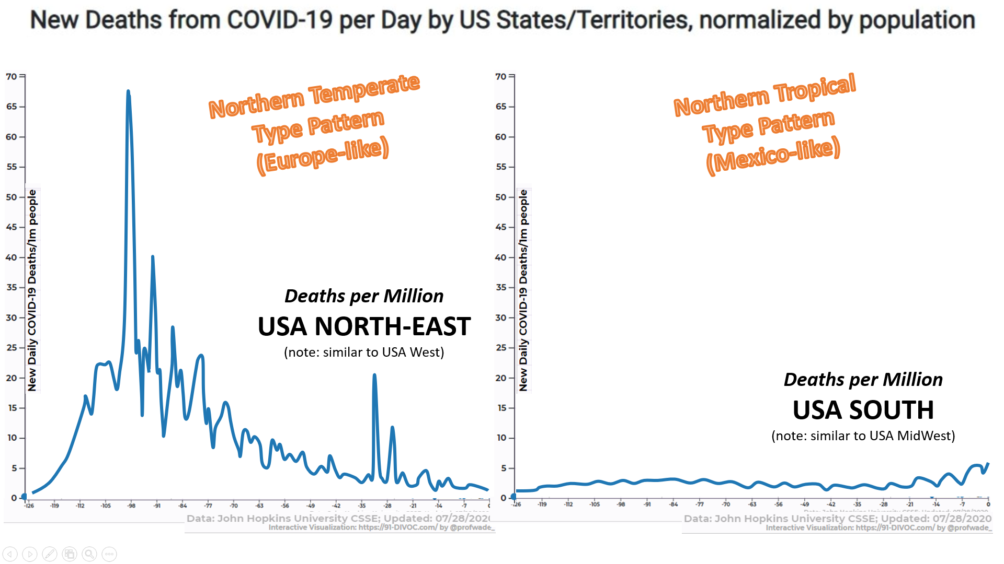
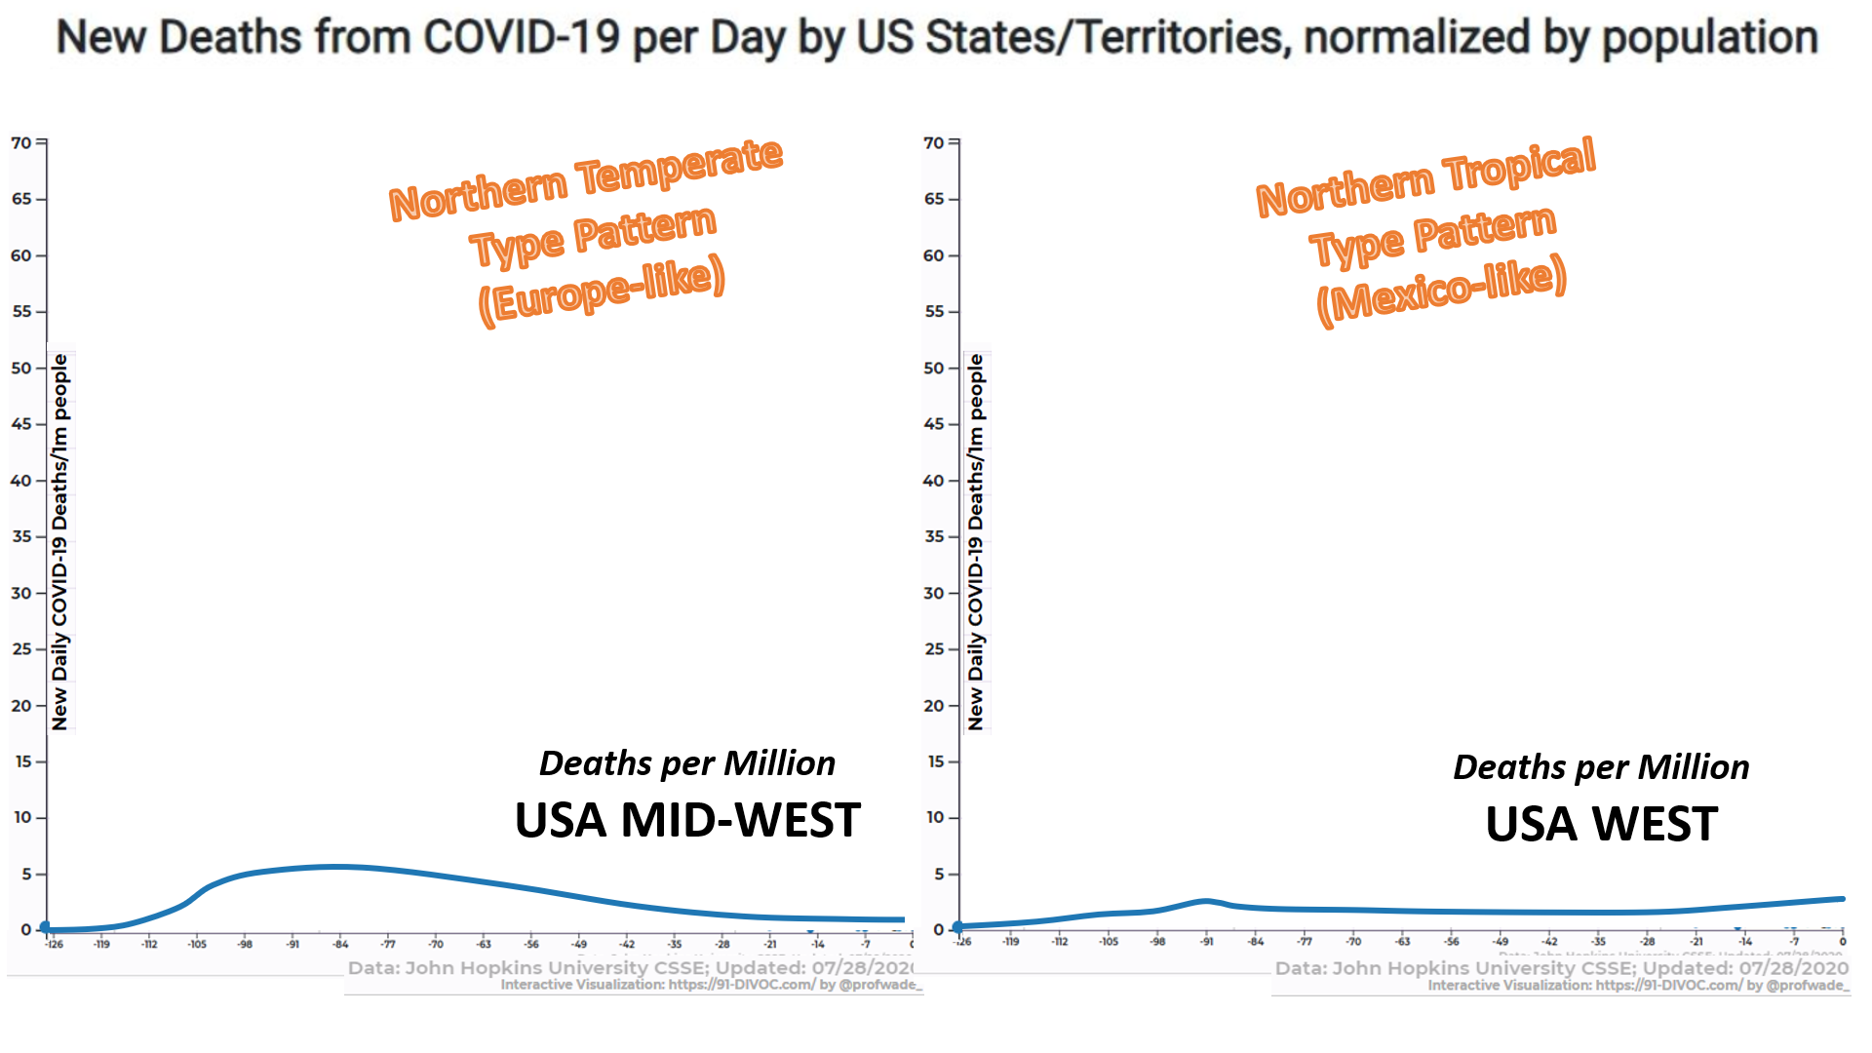

Source: Johns Hopkins data, http://91-divoc.com/pages/covid-visualization/

Hopefully it is clear in this section that there is an enormous seasonal/regional effect in viral triggering, independent of lockdown or restrictions severity. Again, this powerful effect dramatically changes both the severity of the impact, and the timing/pattern of the impact.

B5: PROPORTIONATE MEASURES – OR IRRATIONAL HYSTERIA?

When any virulent pathogen is spreading in a society and has significant impact potential, then smart measures should always be used to protect the at risk and reduce impact on our services. These measures including hand washing, face coverings (but of course self-isolation is best) if you have symptoms, avoiding large crowds if you feel at risk, etc. These are very sensible approaches to such a threat. They should be used during any epidemic or Flu season and will have a notable impact. Similarly, more attention being paid to the movement of staff and visitors into and between care home could be reviewed and will serve to remind all countries on how to prevent the widespread mortality we have seen in these settings.

Today, the 18th of August as we are bombarded by the rising cases and threat of more lockdowns, I now stand with many of my colleagues and friends in frank disbelief. I regularly encounter people throughout the day who display fear, frustration, anger and anxiety about what is happening and our response to it.

The following points now become important:

- The curves flattened many months ago, the burden on the health service avoided, mission accomplished? No, now we are told not to flatten the curve but to eliminate the virus much the same way New Zealand has. A “zero Covid” policy is the only way forward we are told. There are many flaws with this, but I’ll start with the low hanging fruit. Comparing New Zealand to the UK is like comparing a village to a city. New Zealand is a 3hr flight from the nearest large landmass, the continent of Australia with its 25M population. The UK by comparison is within a 3hr flight from 300M people, its capital city London one of the most heavily used airports and financial centres on the continent. Even if “zero Covid” was possible, and it is not, it would only be a matter of days before we saw cases again. In order to achieve “zero Covid” we would have to board up every house, every business, stop most medical procedures (possible including closure of A&E departments) and deploy all members of the police and army to enforce such a policy.

- The impact as determined by all-cause mortality and ICU admissions is similar across Europe, essentially what you would expect for this time of year. This is despite rising cases in many regions (often driven by excessive testing). So, it begs the question, why the alarmist response? As any country scales up PCR testing, we will naturally see a rise in cases. This is to be expected (see above) due to immunity, cross reactivity and previous viral shedding. What we do not have is a corresponding impact in terms of ICU admission or mortality. This is largely due to a majority of the population having an adequate T-Cell immune response, a concept that helps us understand why some people in families become infected and others do not. Cases are on the rise, yet significant impact is not. What we have is what can be described as a “Casedemic” (i.e. a rise in cases with little or no serious impact).

- Mass-testing with PCR-type kits has become a major problem in itself, happening as it is after the epidemic itself has passed. The PCR test does NOT test for live, viable virus. Rather it looks for one or two “viral fragments” associated with the Sars-CoV-2 virus. Most concerning is the fact that the PCR test picks up all the people who had the infection in the past, and are now completely fine; the problem is that viral fragments remain in one’s system weeks or even months after the virus itself has been banished. Another issue is that the PCR test can suffer from approximately 0.5% “false positives”. Roughly speaking, if you test a thousand people and find 10 “cases” – many of these can be false positives. It is simply not fit for purpose after an epidemic (i.e. real impacts on sickness and mortality) – has passed. The following plots should illustrate this serious problem very clearly:

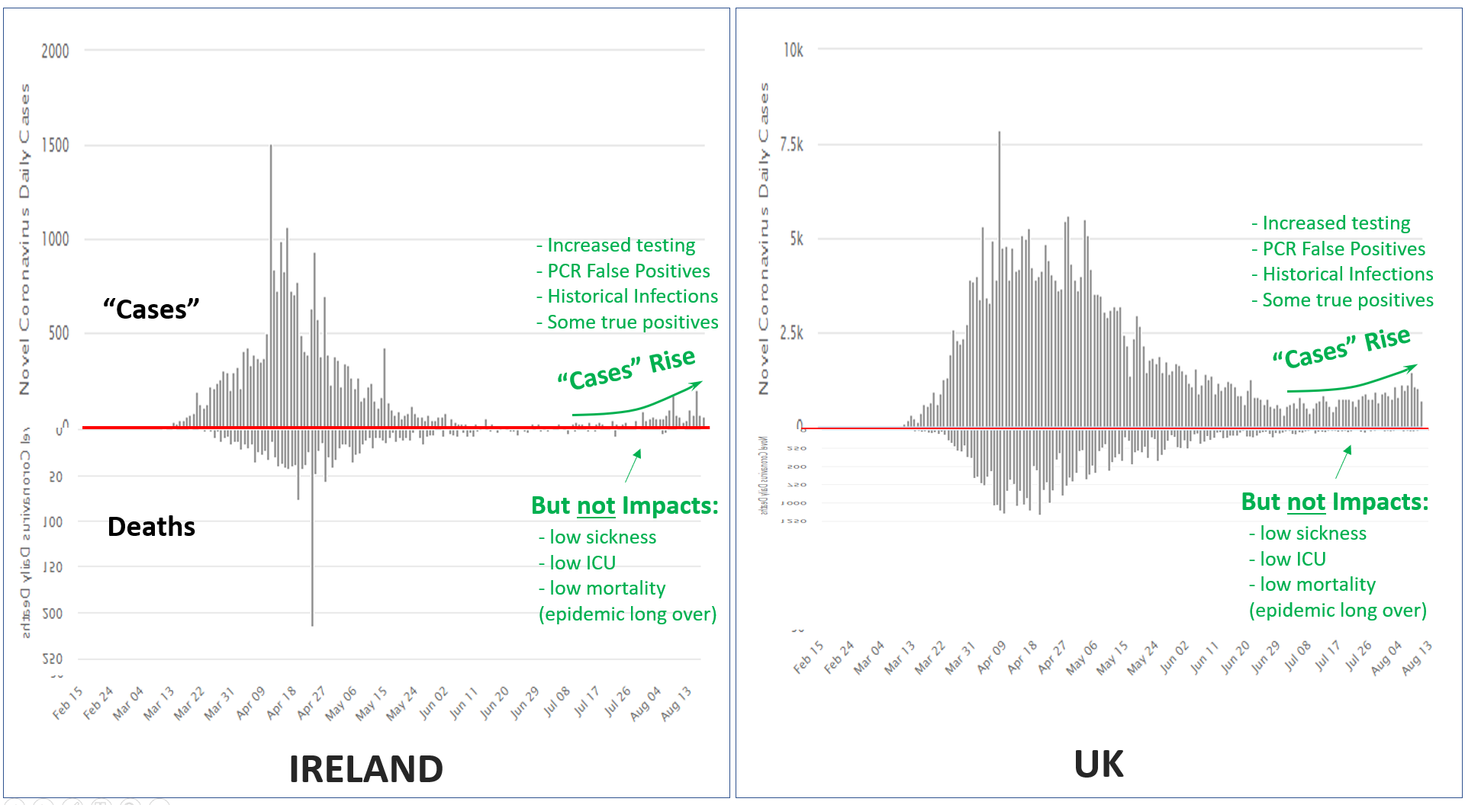
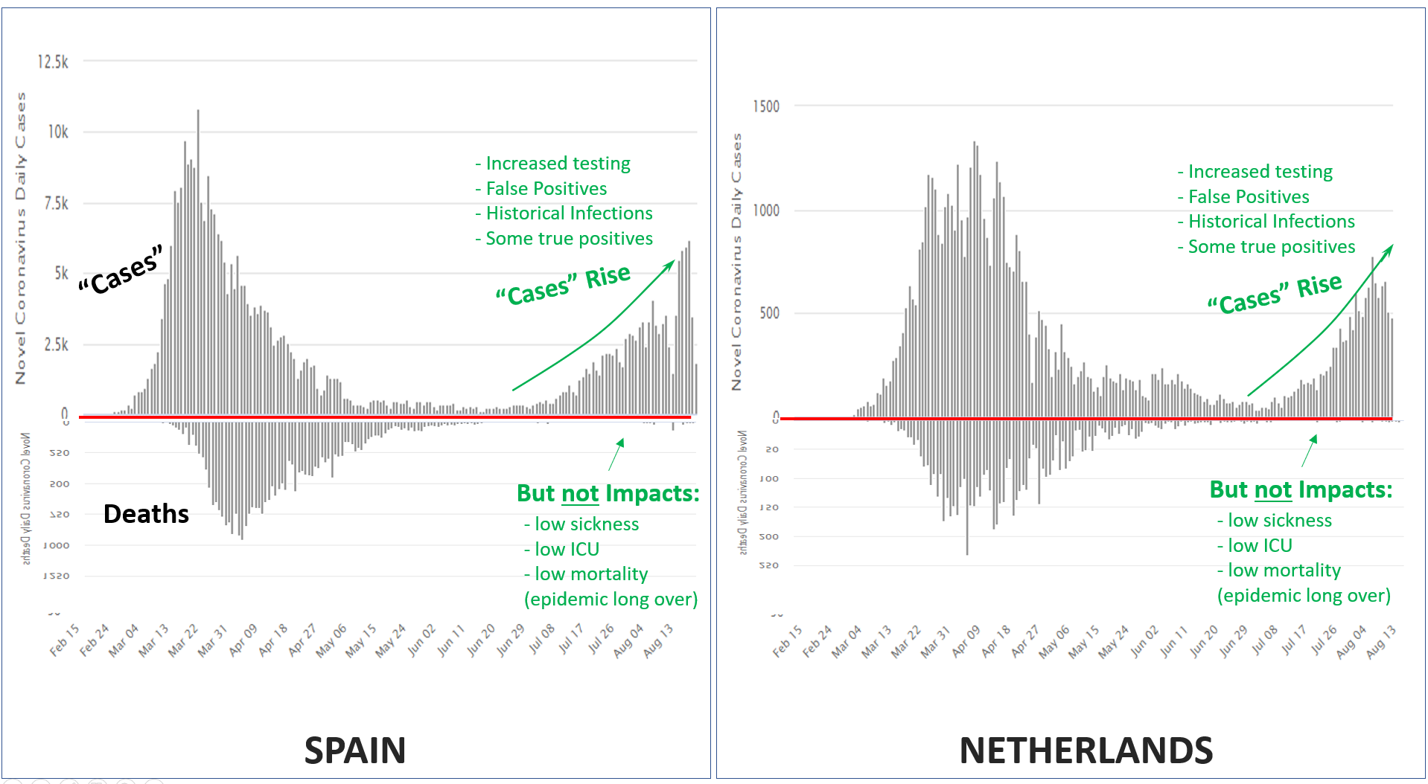
Above plots: the striking shift from impactful epidemic, to non-impactful endemic presence in the population.

Source: https://www.worldometers.info/coronavirus/

- Another crucial point to note is that an increase in the presence of Sars-CoV-2 in humans as we head into the winter, should not be a surprise. When we test for influenza through the year, we see this too (see graph below). The key question is “do we see an epidemic-type level of impact on sickness and death?” As was obvious in the last section, the answer is “no”. The reality is that the epidemic has passed now for this season, via:
  - the passing of the most susceptible people, sadly
  - the development of herd immunity broadly in the population (NOT as determined by antibody testing, which undercounts hugely)
  - Some seasonal changes to human immunity and virus activity
  - Other miscellaneous factors

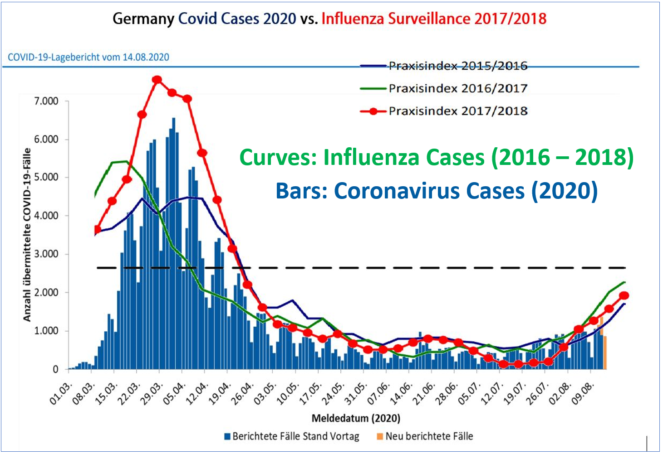
Above plot: Sars-CoV-2 behaving very like seasonal influenza (x-axis shifted to overlay graphs)
Refs for plots above:
1. https://www.rki.de/DE/Content/InfAZ/N/Neuartiges_Coronavirus/Situationsberichte/2020-08-14-de.pdf?__blob=publicationFile
2. https://influenza.rki.de/Wochenberichte/2018_2019/2019-39.pdf

- The ever-looming threat of a second lockdown now confronts the British people - our society faces more fear, paranoia, anger, depression, suicide, and mental health disorders. If the British people have to endure this for the foreseeable future, they at least deserve to hear the other side of this debate; that there may be an alternative to rolling lockdowns that will lead to missed cancer diagnoses, closure of schools, businesses destroyed, jobs lost, travel restricted, domestic violence, isolation and depression increased, mental health disorders in children on the rise and operations postponed or cancelled. It is important to remember, it is the poor and working class who will suffer the worst impacts from this. We are a long way from solving our health system and our housing crisis. Globally, this lockdown will drive millions into poverty.
- The mandating of face masks based on little to no evidence is Orwellian at best. The evidence as provided by our experts at the peak of this pandemic was that they were useless, now they are essential. So essential in fact, that not only are they mandatory, this is enshrined in law and punishable by custodial sentence. One could do a fair bit of damage to person or property in the UK and not incur a 6-month custodial sentence.
Masks may or may not have a benefit, and it is not unreasonable to invite people to wear these during an epidemic or pandemic when rising infections translate to significant morbidity and mortality - but enforcing face coverings and threatening prison on those that do not comply is the antithesis of Western Civilisation. All public health advice should be evidence based and voluntarily followed.

- An analogy: let’s say we have reduced injuries and mortality from car crashes down to tiny numbers, a huge success – the curve flattened beyond every expectation. But then we start obsessing on the thousands of bangs, scrapes, broken wing mirrors etc. – and make these “Car Impact Cases” into the new, paranoid focus. We know that the PCR test finds dead viral fragments from an old infection – so to complete our analogy, we would be recording scratches today that actually occurred weeks or months ago. Thus, our fixation with these “Car Impact Cases” would cause us to stop all driving in the UK, thus eliminating all accidents - but not achieving any notable benefit in what is important. Namely of course - actual deaths and serious injuries. Hopefully this helps to illustrate just how far we have deviated from the original (reasonable) intentions of March 2020 – where we all agreed to protect the hospitals and flatten the curve. But have people actually stopped to think about how extreme and irrational we have now become?

- If we are to embark on a multi-year journey of economic depression, ruining young people’s hopes and dreams of buying homes, expanding or opening businesses, travelling or even enjoying a normal college experience, at least let it be built on sound empirical evidence. Let’s allow Nobel Laureates to be heard and not shouted at, that the one-dimensional view of NPHET be challenged by other experts, that the vaccine search continue and that no vaccine is distributed without the most rigorous of safety checks and that it is never made compulsory. Consent through education is the only way forward.

There is a way to avoid the economic Tsunami that awaits us. It resides in a better understanding of the above, a more consensual way to arrive at desired outcomes, a focus on nursing homes going forward during any epidemic or severe Flu season, the opening of schools, of restaurants, of pubs, of nightclubs, of avoiding the environmental carnage of disposable masks, gloves ,signs, plastic shields. We have co-existed with pathogens since our inception. Every so often a dreaded killer comes a long that wipes out millions. Our experience of Covid 19 should serve as a shot across the bow as to how unprepared we were for such an event. We will prevail against it; the susceptible can get a vaccine to limit impacts should it rear its ugly head again in the winter. It is time to think about a brighter future and with the correct science-based thinking and brave political will, it can be realised.

