Thankfully we are now in a very different place than in February 2020 when we were first impacted by Sars-CoV-2. Our understanding has advanced enormously since then—we know who the vulnerable are, and how best to clinically treat COVID-19 (the disease that results from contraction of the virus). We know that the infection fatality rate of the disease is within the envelope of a nasty influenza, and that, like influenza, Sars-CoV-2 is a seasonal virus. We had our first wave in March and this winter we are experiencing a seasonal resurgence as is the norm for respiratory viruses. The virus can now be said to be endemic in the population, like many before it. It is part of the common cold family of viruses.
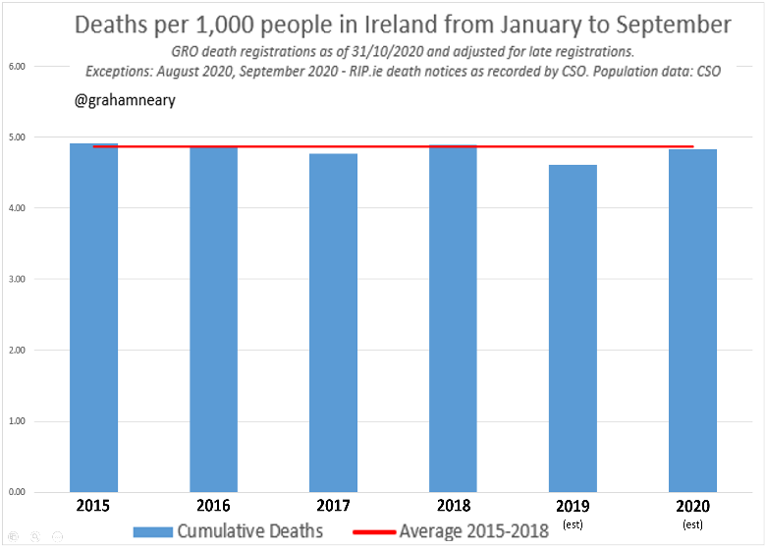
Apart from the very short, fast spike in Covid-19 deaths in April when the virus was new, overall mortality for the year 2020 has not been any higher than previous years. This contrasts with the terrible predictions of the modellers who advise the government. In fact, the median age of death for those who died, was generally higher than the average life expectancy age. Were you fully aware of this fact? All lives are important, but perspective is crucial to apply also.
Note that ~95% of those who died from COVID-19 in Ireland were people for whom ICU care was inappropriate, due to the presence of other terminal illness or a debilitated state.
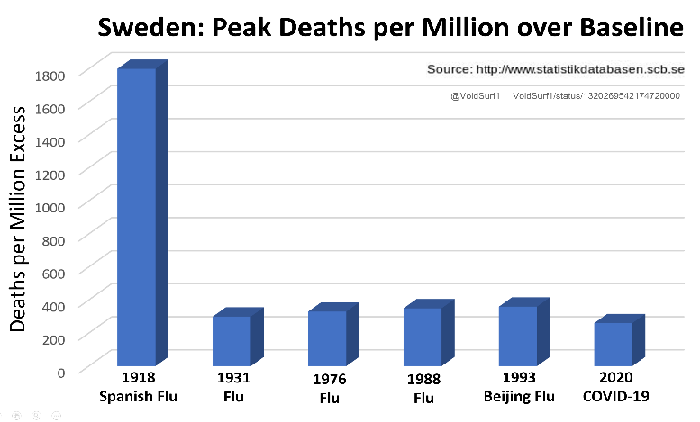
In analyses, no-lockdown Sweden had a similar mortality impact as Ireland. Sweden stuck to the WHO October 2019 Pandemic Guidelines, rather than doing lockdowns. Note also in the graph opposite that Covid-19 in no-lockdown Sweden had similar impact to prior bad flu years. Were you aware that COVID-19 impact is nowhere near the impact of 1918 Spanish Flu? Importantly, Spanish Flu drove around 100 times more mortality in healthy under-60’s than COVID-19 does.
Importantly, more than 20 analyses of real-world data have indicated that lockdown interventions result in little mortality benefit: https://tinyurl.com/LockdownPapers

Do lockdowns cause more harm than good?
It is an unprecedented measure to lockdown a country, and it contradicts the WHO’s own 2019 pandemic guidelines. These guidelines acknowledge that lockdowns have enormous negative consequences on both economy and society, and have very limited benefits. The Irish government instituted a severe level five lockdown based on positive PCR test ‘cases’ using highly questionable ‘modelling’. This action has resulted in the loss of 100,000 Irish jobs, and we now have 35% youth unemployment. New lockdowns being driven in December/January 2021 will lose a further ~150,000 Irish jobs. We are destroying society.
Lockdown causes increased death from untreated heart disease and cancers – people ignore symptoms they would otherwise have had checked out; screening programs are suspended or reduced, meaning people present with more advanced disease. Mental health is severely impacted by lockdown. Many people experience depression and anxiety as a result of enforced isolation and the financial impacts of job or business loss. It is now clear from a UK study, that in the period since last May, the excess deaths occurring have been dominated by the 14-44 and 45-64 age groups, with only a very small proportion even carrying the virus. These deaths would therefore be more related to the negative effects of lockdown. Crucially, there will be hugely more ‘life years’ lost when these younger people die, compared to the aged people who represent the COVID-19 deceased. Lockdown is an unprecedented and blunt instrument for managing COVID-19. Public health is not just the absence of one disease. Excellent resource here: https://gbdeclaration.org/
The PCR Test – Inappropriate for Policy Setting
Never before have we tested non-symptomatic people in the general community for a respiratory disease on the scale we do now. Like lockdowns, this is unprecedented. Yet it is the basis for the imposition of draconian restrictions. Normally, a person presents to their doctor with symptoms and a test helps confirm the clinical diagnosis. Now we test people in an almost random method. The PCR test will pick up many ‘meaningless positives’ including people who have dead viral fragments post infection. The test manuals themselves stipulate symptomatic people only. See short explanation here: https://tinyurl.com/ProblemPCR
What is the path forward from here?
Focus on established epidemic management protocols. Target protection measures for the vulnerable. Target testing at high-risk work environments such as care homes. Incorporate rapid antigen test for far cheaper and faster results. Vitamin D level testing and awareness particularly among high-risk groups would have had meaningful impact, as studies have shown that those hardest hit by COVID-19 have very low D levels. Adjusting diet to an ‘Eat Real Food’ model to reduce high blood sugars and diabetic physiology while promoting fresh air and exercise will have a positive impact on people’s health. Draconian lockdowns in contrast have a negative impact on many people’s health and stress levels, hindering more than they help. Please see https://covidrecovery.ie/ for further information on all of the above. Please contact your local politician and make them aware of this information.

